Student Name : LAKSHITA SWETA D/O KATHIRESAN

Group : ____________SCSJ___________

Date : ___________28/8/2026_________

LAB 1: UNDERSTANDING NETWORKING WITH INTERNET TECHNOLOGIES
Exercise 1A: communication architectures

Classify the following installed communication modules into their appropriate layers in the TCP/IP architecture(ie protocol stack in figure 1.1):

Internet Protocol (IP) : Network Layer
Network controller card
(eg. Realtek PCIe GBE Family Controller) : Data Link Layer

Exercise 1B: ADDRESSING

Classify the use of the following addresses into their appropriate layers in the TCP/IP architecture(protocol stack in figure figure 1.1):

Port number : Transport Layer
IP address : Network Layer
MAC address : Data Link Layer

Exercise 1C: PHYSICAL/MAC/ETHERNET ADDRESSES

Determine the MAC address of your laboratory PC:

MAC Address : A4:BB:6D:61:CC:90
Manufacturer : Intel ® Ethernet Connection (11) I219-LM (DELL Inc)

Exercise 1D: IP ADDRESSES

NTU IP address range(NOT your PC IP address) : 155.69.1.0 to 155.69.1.255

Determine the special uses of the following IP addresses:

{ 127, <any> } : local host or loop back address
{ 172.21, <any> } : Private internal address

Exercise 1E: DYNAMIC HOST CONFIGURATION PROTOCOL (DHCP)

Determine the following for your laboratory PC:

DHCP Enabled : Yes
DHCP Server : 155.69.3.8
Network/Subnet Mask : 255.255.240.0

What is your IP address(from Ipconfig) :10.96.185.225
What is the reported IP address from website (try https://whatismyipaddress.com/ ) : 155.69.185.225

Who is the owner of the IP address reported by the website? Nanyang Technological University

Exercise 1F: PORT NUMBERS

Determine the well-known ports for the following services:

TELNET : 23
Simple Mail Transfer Protocol (SMTP) : 25
Quote of the Day Protocol : 17
Domain Name Service (DNS) : 53
Hyper-Text Transfer Protocol (HTTP) : 80

Exercise 1G: DOMAIN NAMES

How do you register/buy a domain name under .sg, e.g. myweb.per.sg?
Answer: To register/buy a domain name under .sg, you must have a Singaporean address and either SingPass or NRIC. Then check if the domain name is available, then purchase and register it through SGNIC.

Exercise 1H: DOMAIN NAMES/IP ADDRESSES TRANSLATION
- DOMAIN NAME SYSTEM (DNS)

Determine the followings:

Local DNS servers for your laboratory PC : 155.69.3.7 , 155.69.3.8 and 155.69.3.9

Authoritative DNS servers for ntu.edu.sg : 155.69.254.5 and 155.69.254.230 / dnstex.ntu.edu.sg and dnstex1.ntu.edu.sg

IP address of domain name www.ntu.edu.sg : 155.69.3.7

What is the command to show the entries in the DNS cache? Answer: ipconfig / displaydns
What is the command to clear the entries in the DNS cache? Answer: ipconfig / flushdns

Exercise 1J: PROPRIETARY MICROSOFT WINS

Determine the followings for your laboratory PC:

NetBIOS/Host name :hw1-r1-v07
Primary WINS server :155.69.5.54
Secondary WINS server :155.69.5.154

Exercise 1K: DEFAULT GATeWAY

IP address of default gateway : 10.96.191.254

Exercise 1L: IP ADDRESS/PHYSICAL ADDRESS TRANSLATION
- ADDRESS RESOLUTION PROTOCOL (ARP)

Physical MAC address of default gateway : 00-00-0C-9F-F0-F0

Exercise 1M: NETWORK REACHABILITY - PING COMMAND

ping your neighbour's PC and run arp command again. Do you see your neighbour's PC listed? Why?
Answer: Yes. When pinging my neighbour’s IP, arp request is performed and mapping of physical address is saved into arp cache table.

Physical address of neighbour's PC : A4-BB-6D-61-C9-AE

Exercise 1N: TRACE ROUTE - TRACERT COMMAND

How many routers are separating your laboratory PC and the local DNS servers?

Answer: Overall is 4. 4 routers before reaching the local DNS server.

Number | Local DNS Server | Routers
1 | 155.69.3.7 | 10.96.191.253  172.30.146.5  172.30.146.194  172.30.2.189  dns-sdc-02.ntu.edu.sg [155.69.3.7]  Trace Complete
2 | 155.69.3.8 | 10.96.191.253  172.30.146.5  172.30.146.194  172.30.2.189  ndc-dns-dhcp-01.ntu.edu.sg [155.69.3.8]  Trace Complete
3 | 155.69.3.9 | 10.96.191.253  172.30.146.5  172.30.146.194  172.30.2.189  sdc-dns-dhcp-02.ntu.edu.sg [155.69.3.9]  Trace Complete

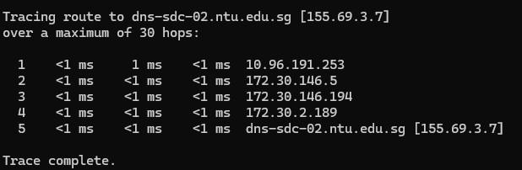
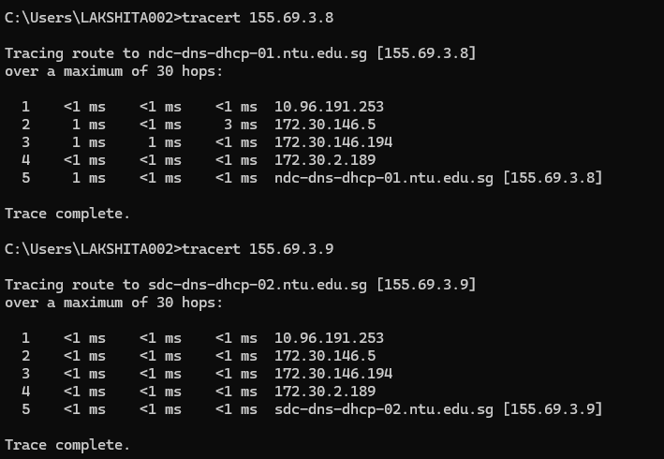

Run arp command again. Can you find the MAC address of the DNS servers? Why?

Answer: No. It because devices outside of local subnet are only reachable through gateway and not directly.

